Facebook Marketplace Dataset
Solved by Subhadip Banik (subhadipbanik9@gmail.com)

Questions, Codes and Answers
import pandas as pd
df = pd.read_csv(r"C:\Users\subha\OneDrive\Desktop\Programming\python\dataAnalytics\Finlatics\ML_Research\Facebook Dataset\Facebook_Marketplace_data.csv")
df.set_index('status_id', inplace = True)
df['status_published'] = pd.to_datetime(df['status_published'],format='%m/%d/%Y %H:%M')
df = df.dropna(axis= 'columns', how = 'all')

- How does the time of upload (`status_published`) affect the `num_reaction`?
DF=df[['status_published','num_reactions']]
DF.set_index('status_published', inplace = True)

Import matplotlib.pyplot as plt

df1=DF['num_reactions'].resample('W').sum()
df1 = pd.DataFrame(df1)
df1.plot(kind='bar',y='num_reactions',figsize=(15,5)).get_xaxis().set_visible(False)
plt.xlabel('Week_Date')
plt.ylabel('Total Reactions')
plt.title('Total Weekly Reactions')
plt.xticks(rotation=45)
plt.tight_layout()
plt.show()
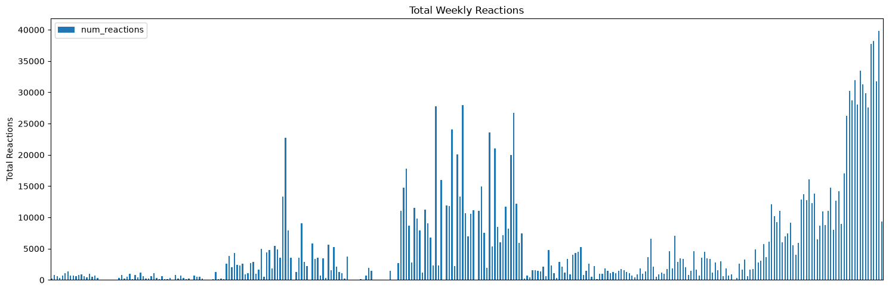

df1=DF['num_reactions'].resample('YE').sum()
df1 = pd.DataFrame(df1)
#import matplotlib.pyplot as plt
df1.plot(kind='bar',y='num_reactions',figsize=(15,5))#.get_xaxis().set_visible(False)
plt.xlabel('Starting date')
plt.ylabel('Total Reactions')
plt.title('Total Yearly Reactions')
plt.xticks(rotation=45)
plt.tight_layout()
plt.show()
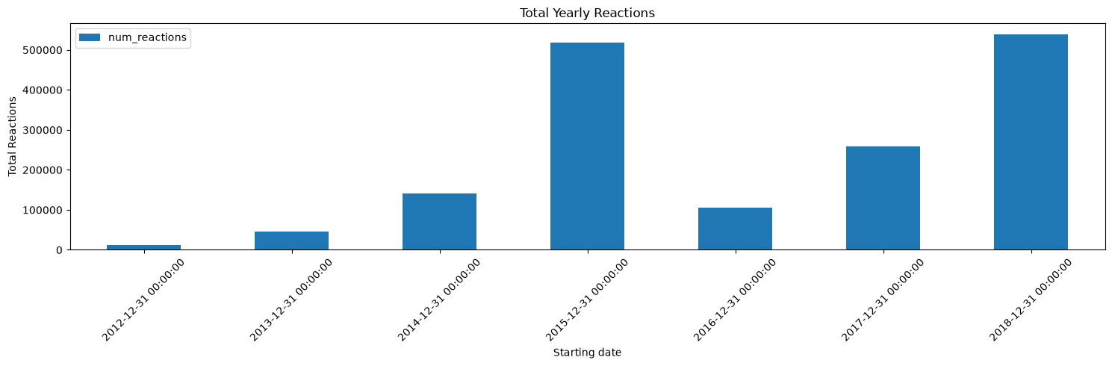

DF.groupby(DF.index.hour)['num_reactions'].sum().plot(kind='bar',y='num_reactions')
plt.xlabel('Hour value')
plt.ylabel('Total Reactions')
plt.title('Total Hourly Reactions')
plt.show()
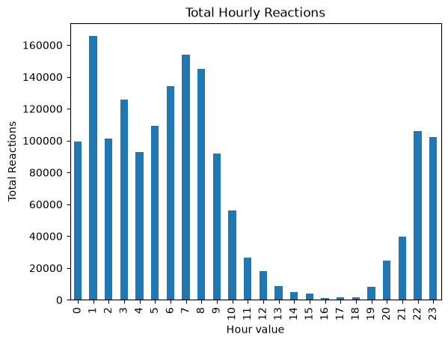
#People are using Facebook at night, skipping office times

DF.groupby(DF.index.dayofweek)['num_reactions'].sum().plot(kind='bar',y='num_reactions')
weekday_sum = DF.groupby(DF.index.day_name())['num_reactions'].sum()
plt.xlabel('Weekday')
plt.ylabel('Total Reactions')
plt.show()
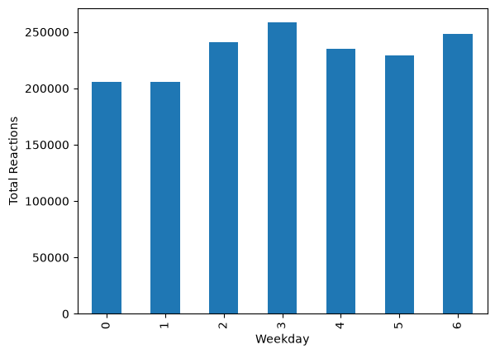

- Is there a correlation between the number of reactions (num_reactions) and other engagement metrics such as comments (num_comments) and shares (num_shares)? If so, what is the strength and direction of this correlation?
DF['reaction_range'] = pd.cut(DF['num_reactions'], bins=[100*i for i in range(0,49)])
DF.groupby('reaction_range')[['num_comments', 'num_shares']].median()
 | num_comments | num_shares
reaction_range
(0, 100] | 1.0 | 0.0
(100, 200] | 20.0 | 2.0
(200, 300] | 166.0 | 20.0
(300, 400] | 42.0 | 6.0
(400, 500] | 20.0 | 2.0
(500, 600] | 21.0 | 3.0
(600, 700] | 22.0 | 3.0
(700, 800] | 35.0 | 3.0
(800, 900] | 121.0 | 18.0
(900, 1000] | 13.0 | 1.0
(1000, 1100] | 24.5 | 5.5
(1100, 1200] | 97.5 | 37.5
(1200, 1300] | 34.0 | 4.0
(1300, 1400] | 771.0 | 254.0
(1400, 1500] | 39.5 | 3.5
(1500, 1600] | 28.5 | 5.5
(1600, 1700] | 42.5 | 4.0
(1700, 1800] | 161.0 | 30.0
(1800, 1900] | 22.5 | 1.5
(1900, 2000] | 23.0 | 2.0
(2000, 2100] | 25.0 | 2.0
(2100, 2200] | 19.0 | 1.5
(2200, 2300] | 9.0 | 1.5
(2300, 2400] | 14.0 | 1.0
(2400, 2500] | 22.0 | 0.0
(2500, 2600] | 64.0 | 28.0
(2600, 2700] | 23.0 | 2.0
(2700, 2800] | 26.0 | 1.0
(2800, 2900] | 34.5 | 3.5
(2900, 3000] | 147.5 | 43.5
(3000, 3100] | NaN | NaN
(3100, 3200] | 21.5 | 0.5
(3200, 3300] | NaN | NaN
(3300, 3400] | NaN | NaN
(3400, 3500] | NaN | NaN
(3500, 3600] | 12.0 | 0.0
(3600, 3700] | 175.0 | 101.0
(3700, 3800] | 156.0 | 93.0
(3800, 3900] | NaN | NaN
(3900, 4000] | 77.0 | 12.0
(4000, 4100] | 61.0 | 6.0
(4100, 4200] | 104.0 | 3.0
(4200, 4300] | NaN | NaN
(4300, 4400] | 24.0 | 3.0
(4400, 4500] | 633.0 | 257.0
(4500, 4600] | NaN | NaN
(4600, 4700] | NaN | NaN
(4700, 4800] | 50.0 | 1.0

- Use the columns status_type, num_reactions, num_comments, num_shares, num_likes, num_loves, num_wows, num_hahas, num_sads, and num_angrys to train a K-Means clustering model on the Facebook Live Sellers dataset.
import numpy as np
import matplotlib.pyplot as plt
from sklearn.preprocessing import LabelEncoder
from sklearn.preprocessing import StandardScaler
from sklearn.cluster import KMeans

DF = df[['status_type','num_reactions','num_comments','num_shares','num_likes','num_loves','num_wows','num_hahas','num_sads','num_angrys']].copy()

DF.loc[DF['status_type']=='photo'] = 0
DF.loc[DF['status_type']=='video'] = 1
DF.loc[DF['status_type']=='status'] = 2
DF.loc[DF['status_type']=='link'] = 3

DF['status_type'] = (DF['status_type']).astype(int)

DF.info()

<class 'pandas.core.frame.DataFrame'>
Index: 7050 entries, 1 to 7050
Data columns (total 10 columns):
# Column Non-Null Count Dtype
--- ------ -------------- -----
0 status_type 7050 non-null int64
1 num_reactions 7050 non-null int64
2 num_comments 7050 non-null int64
3 num_shares 7050 non-null int64
4 num_likes 7050 non-null int64
5 num_loves 7050 non-null int64
6 num_wows 7050 non-null int64
7 num_hahas 7050 non-null int64
8 num_sads 7050 non-null int64
9 num_angrys 7050 non-null int64
dtypes: int64(10)
memory usage: 605.9 KB

le = LabelEncoder()
DF['status_type'] = le.fit_transform(DF['status_type'])
scaler = StandardScaler()
DF_scaled = scaler.fit_transform(DF)
wcss = []
for i in range(1,11):
kmeans = KMeans(
n_clusters=i,
random_state=42,
n_init=10
)
kmeans.fit(DF_scaled)
wcss.append(kmeans.inertia_)

- Use the elbow method to find the optimum number of clusters.

plt.plot(range(1,11), wcss, marker='o')
plt.xlabel('Number of Clusters')
plt.ylabel('WCSS')
plt.title('Elbow Method')
plt.show()

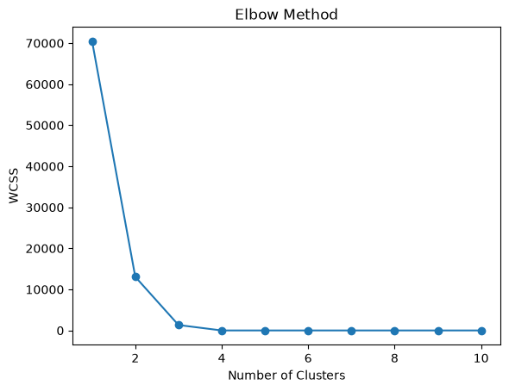

kmeans = KMeans(
n_clusters=3,
random_state=42,
n_init=10
)

clusters = kmeans.fit_predict(DF_scaled)
DF['Cluster'] = clusters
DF['Cluster'].value_counts()
Cluster
0 4288
1 2334
2 428
Name: count, dtype: int64

DF.groupby('Cluster')[['num_reactions','num_comments','num_shares']].mean()
plt.figure(figsize=(8,6))

plt.scatter(DF['num_reactions'],DF['num_comments'],c=DF['Cluster'])

plt.xlabel('Reactions')
plt.ylabel('Comments')
plt.title('K-Means Clusters')
plt.show()
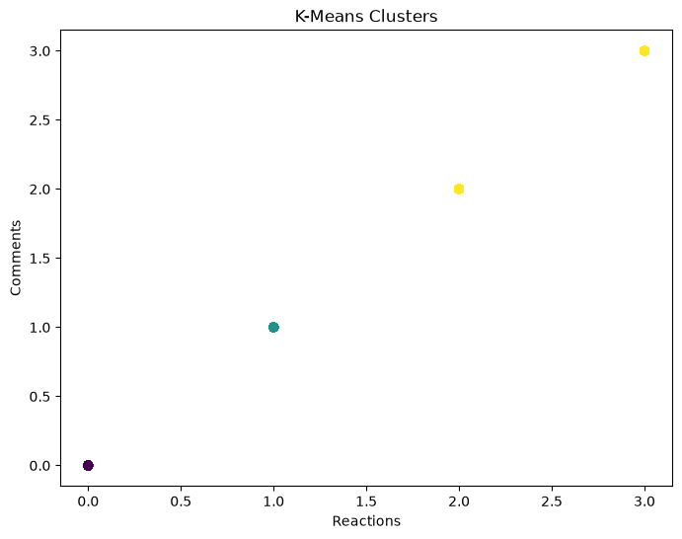

- What is the count of different types of posts in the dataset?
df['status_type'].value_counts()
status_type Count
photo 4288
video 2334
status 365
link 63
Name: count, dtype: int64

- What is the average value of num_reactions, num_comments, num_shares for each post type?
filt = df['status_type'] == 'photo'
(df.loc[filt])['num_reactions'].mean()
np.float64(181.29034514925374)
(df.loc[filt])[ ‘num_comments’].mean()
np.float64(15.993470149253731)
(df.loc[filt])['num_reactions'].mean()
np.float64(2.5538712686567164)

filt = df['status_type'] == 'video'
(df.loc[filt])['num_reactions'].mean()
np.float64(283.4095972579263)
(df.loc[filt])[ ‘num_comments’].mean()
np.float64(642.478149100257)
(df.loc[filt])[‘ num_shares’].mean()
np.float64(115.67994858611826)

filt = df['status_type'] == 'status'
(df.loc[filt])['num_reactions'].mean()
np.float64(438.78356164383564)
(df.loc[filt])[ ‘num_comments’].mean()
np.float64(36.23835616438356)
(df.loc[filt])[‘ num_shares’].mean()
np.float64(2.558904109589041)

filt = df['status_type'] == 'link'
(df.loc[filt])['num_reactions'].mean()
np.float64(370.14285714285717)
(df.loc[filt])[ ‘num_comments’].mean()
np.float64(5.698412698412699)
(df.loc[filt])[‘ num_shares’].mean()
np.float64(4.396825396825397)

